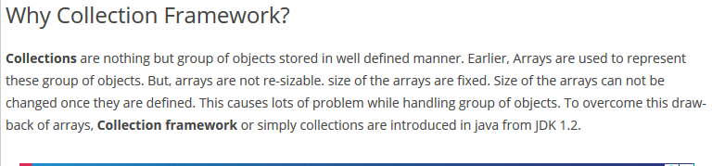

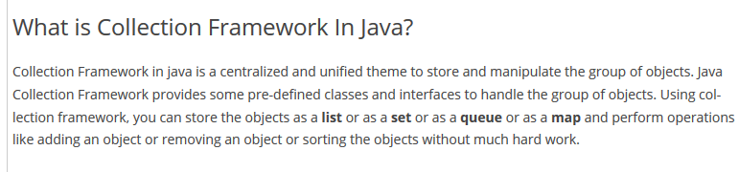

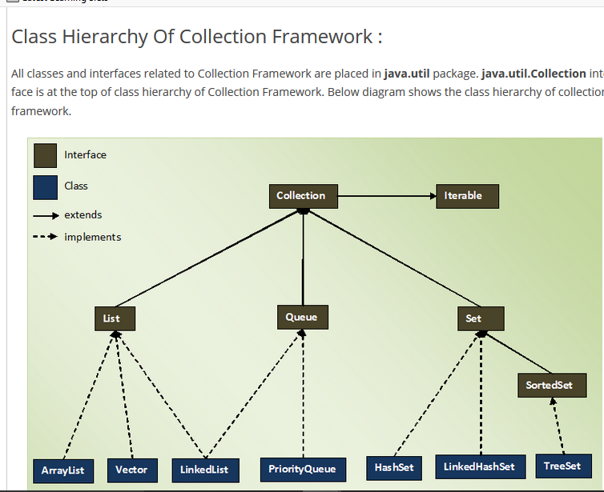

**The entire collection framework is divided into four interfaces**

1. List
2. Set
3. Queue
4. Map

